**ASTRON 1221 Exoplanets Project Report**

Zachary Cohen, Dechong Wang, John Wright

**Motivation and Introduction**

An important subfield of modern astronomy is the study of exoplanets: observing and understanding the properties of planets orbiting stars other than the Sun. One of the most basic questions one can ask about such planets is their size. This question can be answered with one of the most straightforward techniques in exoplanet astronomy: the transit method. This technique uses observations of the brightness of distant stars and infers the sizes of their planets using the magnitude of the fluctuations in the brightness of these stars.

**Methods**

*Data*

We used the following data on the brightness of the star HD209458 from the NASA Exoplanets Archive.

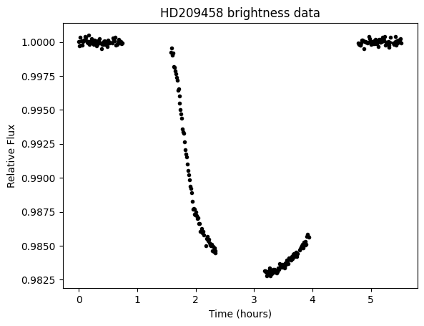

*Calculations*

We fit a ‘box model’ to the data: specifically, the model



Here delta is the change in brightness occasioned by the transit of the planet in front of the star, tau is the duration of the transit, and t_0 is the midpoint of the transit.

Using our estimate for t_0, we were able to estimate the ratio of the planet radius to the star radius using the equation



It is fairly easy to produce good estimates for the three parameters of this model via visual inspection, which we did as the first step of our analysis. We used Bayesian methods to more rigorously obtain estimates with uncertainty quantification.

**Results**

The following chart shows the posterior distributions and MCMC outputs for our data, showing that we were able to get fairly good mixing.

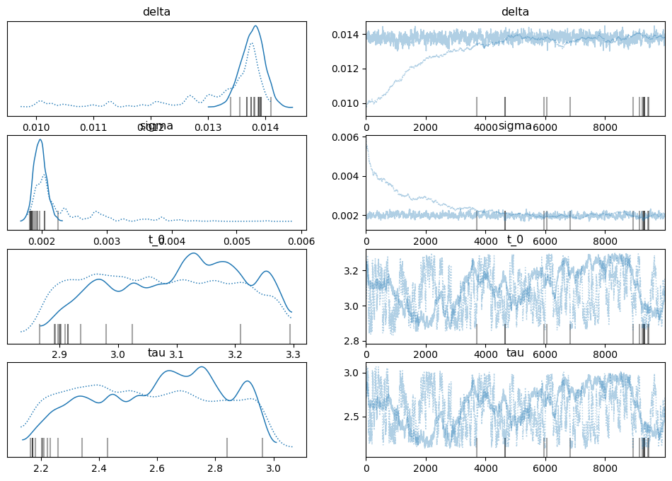

We obtained the following posterior means:

* delta ~ 0.0137
* t_0 ~ 3.1
* tau ~ 2.7

The Bayesian modelling technique which we used also gave us an estimate for the standard deviation of the residuals, or error. The posterior mean for this quantity was about 0.002.

Plotting the predictions of the ‘box model’ with these posterior means gives the following:

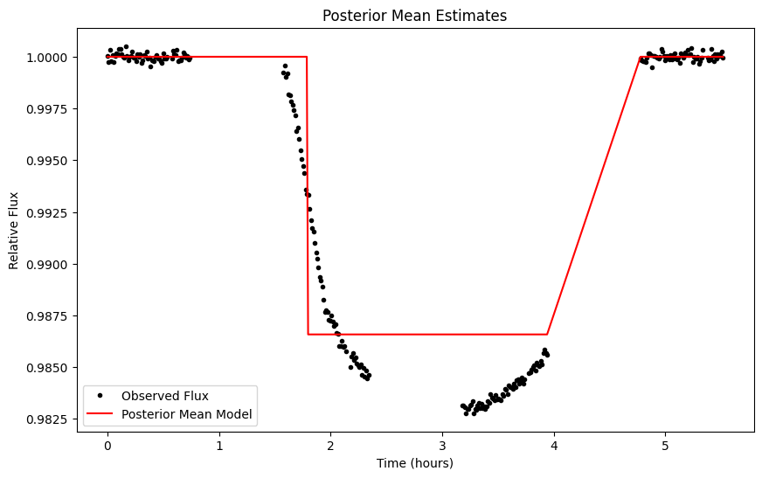

This is not what you might expect of the best fit! However, when compared to another model which is visually superior, plotted below,

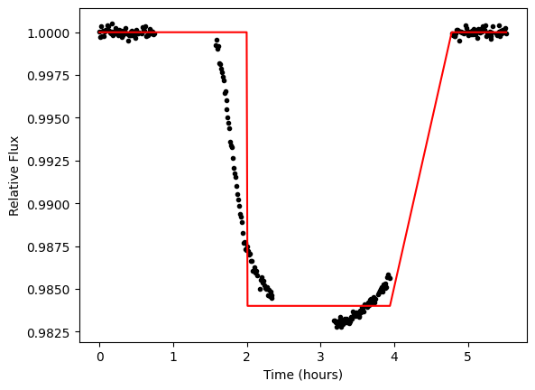

the model using posterior mean estimates has a significantly lower reduced chi-squared statistic (1.1 compared to 2.3). This is of course predictable: the posterior mean is the Bayes estimator for a quadratic loss function such as the reduced chi-squared statistic.

Below is a plot of the posterior predictive distribution for our data:

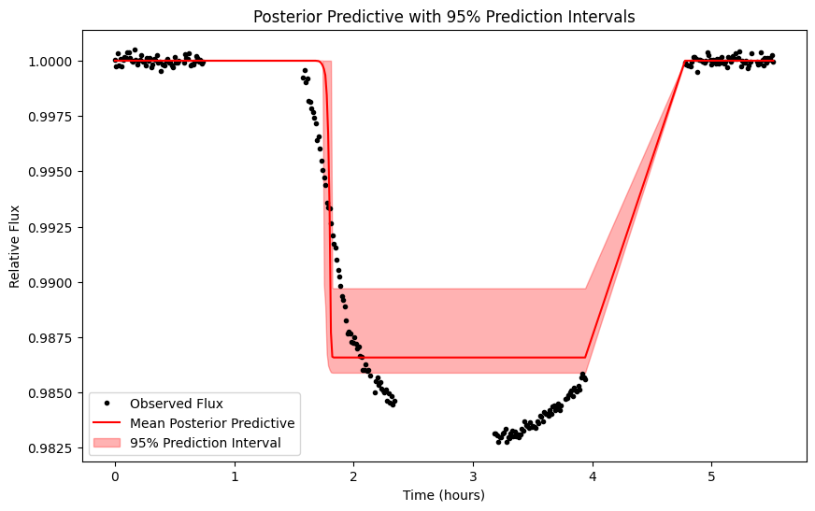

Our estimate for delta implies a planet-to-star radius ratio of about 0.12. Assuming the star is about the same size as the sun, this means the planet is about the size of Jupiter.

**Conclusions**

One of the most obvious things about this model is that it is not a great fit. There are large subsets of the data which fall outside the posterior predictive intervals. This probably means that the box model should be replaced with something more sophisticated in any future work.

However, the main implication of this work - that the planet orbiting HD209458 which produced these data is probably about the size of Jupiter in relation to its sun - stands regardless.

**Contribution Statement**

John Wright used his code to complete the “Motivation and Introduction”, “Methods”, “Results”, and “Conclusions” sections. Dechong Wang wrote the “References” and “AI Statement” sections. Zachary Cohen wrote the “Conclusion” and “Contribution Statement” sections.

All three students completed the relevant programming assignment and made some editorial contributions to the content of the report and presentation.

**AI Statement**

AI was used to generate posterior predictive plots, but not otherwise.